For Office Use Only:
Registration Fee Paid: (Check #)
(Amount)

Camper’s Name:
Please Circle Camper’s Requested T-Shirt Size:
YS YM YL S M L XL XXL

MY CHILD / YOUNG ADULT WOULD LIKE TO BE:

Counselor (please check one of the following)

________ Jr. Counselor (Must be 12 years or older, and have attended camp before). Jr. Counselors are required to attend ONE volunteer/employee training session. Please choose one of the below sessions to attend: Wednesday, July 21st at 6:00 pm OR Saturday, July 31st at 9:00am. Trainings will be held at The Arc of Natrona County office (355 N Lincoln St.).

________ Sr. Counselor (Must be 15 years or older, and have attended camp or have previous experience working with individuals with disabilities). Sr. Counselors are required to attend ONE volunteer/employee training session. Wednesday, July 21st at 6:00 pm OR Saturday, July 31st at 9:00am. Trainings will be held at The Arc of Natrona County office (355 N Lincoln St.).

Camper (please check one of the following)

________ My camper requires no assistance

________ My camper receives Waiver services through the Arc, and I would like to access these
services.

_______ My camper does not receive services, however s/he will need assistance at camp. This
assistance may be provided by a junior/senior counselor. (If a certified Arc employee is available, they will be a choice).

________ I would like my camper to have his/her independent provider accompany s/he to camp. (While independent providers are welcome at Arc camp, there is a daily fee of $5 to cover food and other expenses. This payment will be due with the camp application fee/Arc membership). Please remember that independent providers must have a current Arc membership, and attend ONE volunteer/employee training session. Wednesday, July 21st at 6:00 pm OR Saturday, July 31st at 9:00am. Trainings will be held at The Arc of Natrona County office (355 N Lincoln St.).

Camper’s Name:

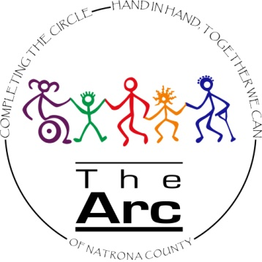

Arc Camp Weekly Schedule

My camper/counselor will be attending the following days/times:

________ My camper/counselor will be attending camp full time, Monday 8/2/21 through Friday 8/6/21, 8:00A.M. – 5:00P.M.

________ My camper/counselor will be attending camp part time. Please fill out schedule below.

Monday Tuesday Wednesday Thursday Friday
(8/2/21) (8/3/21) (8/4/21) ( 8/5/21) (8/6/21)

____________ ____________ ____________ ____________ ____________

---------------------------------------------------------------------------------------------------------------------------------------

Overnight Stay
________ My camper/counselor is 12 years of age or older, and wishes to participate in the overnight stay on August 6, 2021.

Transportation
________ Due to the change in CATC this year we are unable to guarantee transportation, for those with mobility needs, from home to Shepard of the Hills Church (to meet before transport up the mountain). If this is an absolute need, and your child has mobility needs (utilizes a wheelchair) please check this line and we will let you know if we are able to make this work.

